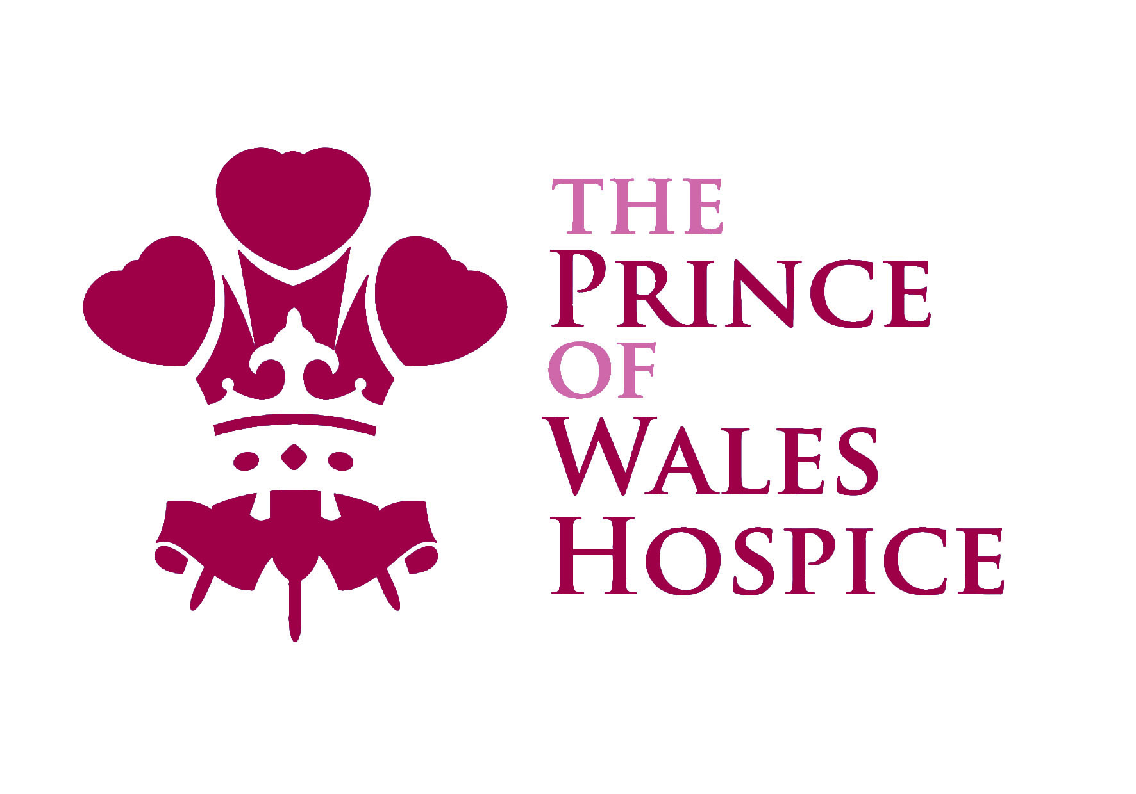

Volunteer Role Profile

Opportunity: Fundraising Volunteer

Team: Fundraising Team

Supported by: A member of the Fundraising Team

Hours available: A variety of hours and days to suit availability, including weekends

Main purpose of the role:

The role of a Fundraising Volunteer is wide and varied! There are lots of opportunities to get involved and you can take part in as many or as few of these as you like, depending on how much time you have available ad what sort of volunteering experience you are looking for.

Most volunteering is at fundraising events or out in our local communities, so it’s lots of fun. You’ll usually be volunteering as part of a team, alongside staff members or experienced volunteers. You will meet lots of supporters and members of the public too.

You’ll also have chance to make a difference in your own local community, if you choose, by putting up posters and helping increase the funds we raise from collecting tins.

Key tasks:

Some of the opportunities available to Fundraising Volunteers are listed below. You do not need to take part in them all!

- Helping out at Hospice events eg. on a registration desk or marshalling routes.
- Representing the Hospice at community fetes and events eg. on a stall.
- Joining a team taking part in street collections / bucket shakes / bag packing.
- Putting up posters in the local community.
- Replacing full collecting tins and re-stocking Hospice merchandise boxes at shops in your local area.

Desirable qualities:

This role would suit someone who is friendly and approachable, who enjoys communicating with people and being part of a team. You will be dependable and will follow through when you commit to take part in something. As an ambassador for the Hospice, you will need to be smartly presented.

The Hospice is committed to the ongoing training and development of volunteers, aiming to provide appropriate training for all volunteers in order to meet statutory obligations and ensure volunteers are well support in performing their role.

