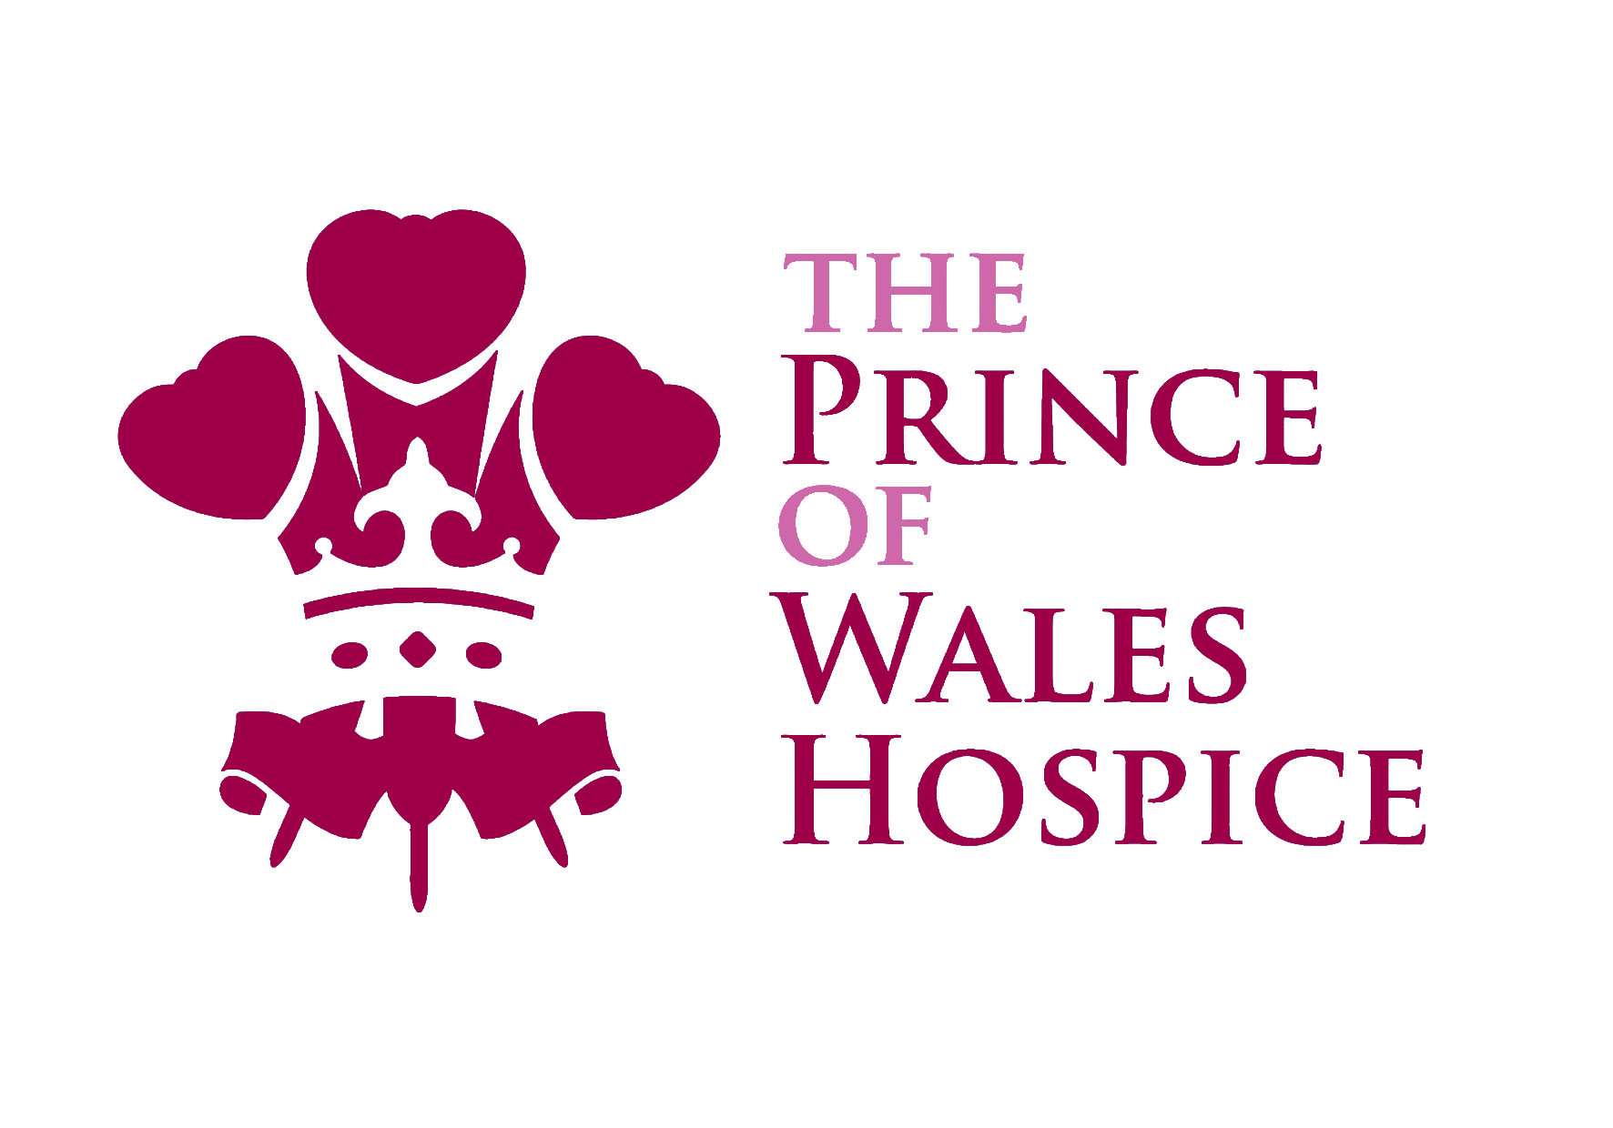

Volunteer Role Profile

Opportunity: Volunteer Complementary Therapists

Team: Complementary Therapy

Supported by: Complementary Therapist

Hours available: A variety of hours and days to suit availability

Main purpose of the role:

The Prince of Wales Hospice provides a complementary therapy service to patients and carers across a variety of clinical areas and locations. The main purpose of the role is to support the delivery of complementary therapy to the Outreach service. This will offer the volunteer the opportunity to enhance their skills and experience in a palliative care setting.

Key tasks:

- Delivery of gentle touch such as massage, Reiki, relaxation techniques, etc.
- Support Outreach service by delivering complementary therapy across different locations.
- Collecting patient and carer feedback.
- To maintain environment and equipment to high standard ensure towels are sent for laundering, stock levels are maintained, etc.

Desirable qualities:

This role would suit someone with a cheerful personality and good communication skills who enjoys meeting and chatting to people. It is important that the volunteer can work as part of a busy team and can also be perceptive to the needs of patients.

A qualification or training in massage and/or Reiki would be desirable.
You should be reliable and committed to learning.

The Hospice is committed to the ongoing training and development of volunteers, aiming to provide appropriate training for all volunteers in order to meet statutory obligations and ensure volunteers are well support in performing their role.

