Here at The Prince of Wales Hospice we are passionate about providing specialist care for people who have an incurable, life-limiting illness.

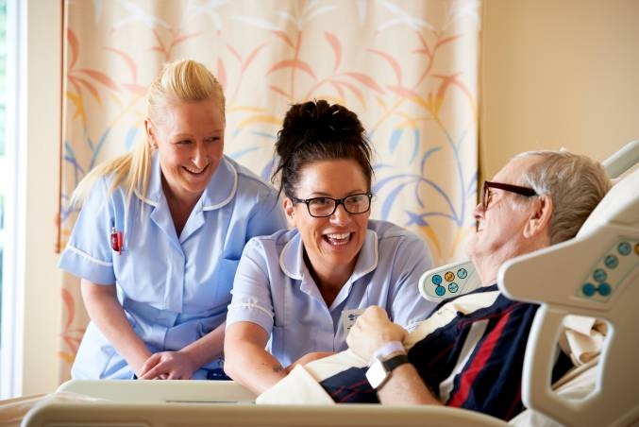
Through our 13-bedroom ward for patients who need round the clock care, and our Day Therapy and Outreach service for people who are living relatively well with their condition, we care for nearly 300 patients a year.

Our specialist team includes doctors, nurses and healthcare assistants, as well as complementary therapists and physical therapists.

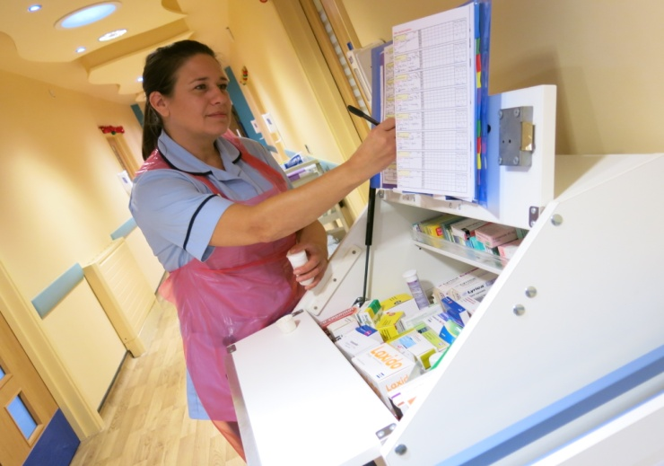
Further emotional and practical support is provided by our family care team. Our chaplain, social worker and bereavement
support co-ordinator work with patients and those who are caring for them – often family members.

We also have a Lymphoedema clinic, treating people with this specific swelling condition, often brought about by cancer treatment. This operates at three different locations, including the Hospice itself.

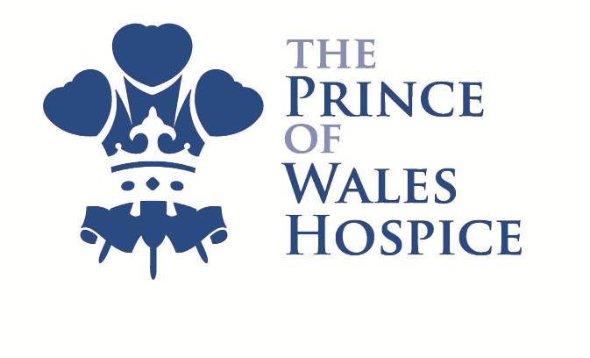
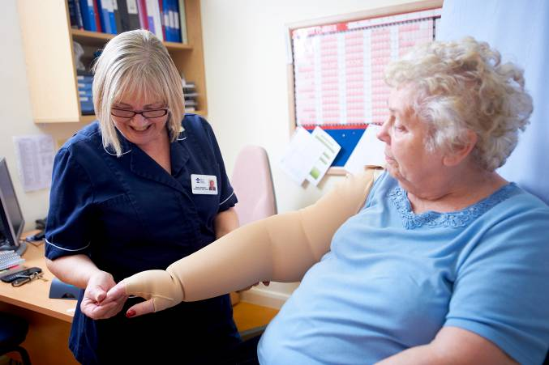
We are committed to working closely with others in the health sector to ensure seamless care for our patients and their
families.

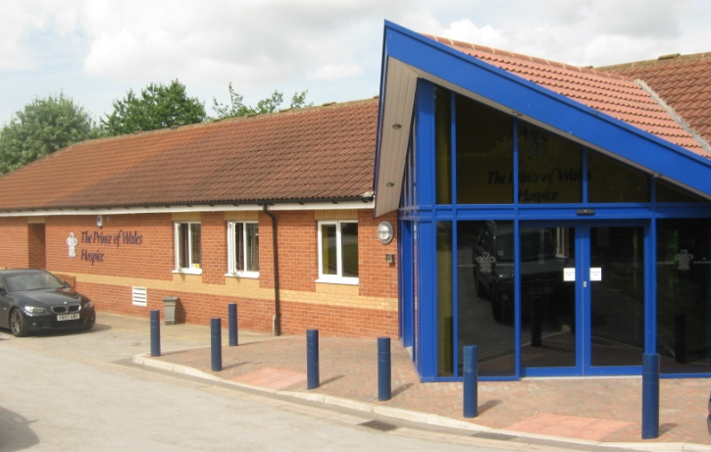
Where we are

The area we cover surrounds the Five Towns of Pontefract, Castleford, Normanton, Featherstone and Knottingley. Most of our patients come from this area, and most of our fundraising is done in this area.

The Hospice itself is in Pontefract, just a few minutes from Junction 32 of the M62. Our modern building also has beautiful gardens for staff, volunteers, patients and visitors to enjoy.

How we are funded

All of our services are provided free of charge to patients and their families, but it costs almost £3m a year, or £7,800 a day, to run the Hospice. Approximately 25% of this comes from the NHS, 20% comes from our charity shops and 55% comes from fundraising events and donations, including legacies.

We encourage staff from both our care teams and supporter services to get involved in raising funds and raising the profile of the Hospice locally.
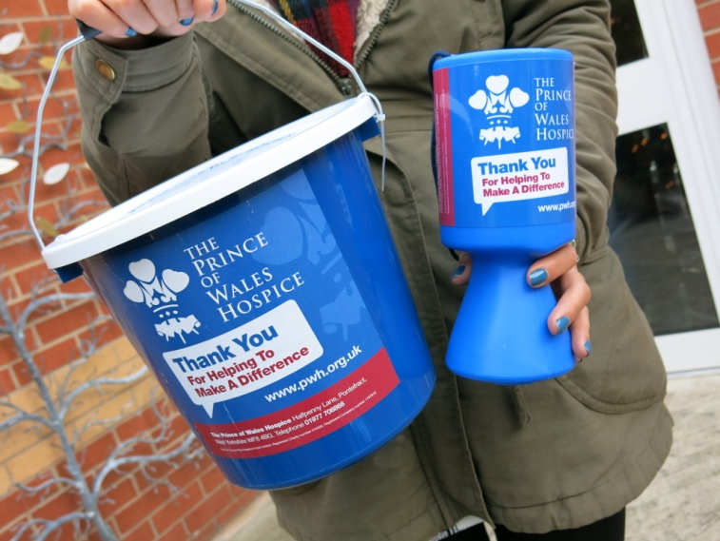
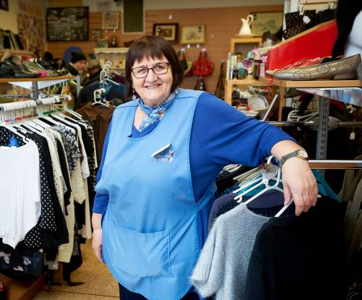
A little bit about the Fundraising and Team

The Fundraising Team sits within the Income Generation Department alongside the Marketing and Retail Teams. The Fundraising Team has been expanded over the past 3 years and is generating more funds and awareness in the local area than ever before.

There are currently nine individuals, mostly working full-time (see the team structure on the next page). Their skills and experience have been gained in both the charity and corporate sectors. A high priority is given to personal development opportunities for individuals and for the team as a whole. The team works to a set of mutually agreed values: enthusiasm, collaboration and co-operation, respect, persistence and communication.

More about the role

The Corporate Partnerships Officer will be line managed by the Fundraising Manager. You will line manage the Corporate Partnerships Assistant. You will work closely with the rest of the Fundraising Team as well as the Head of Retail and Marketing and Communications Officer. You will be responsible for the development, planning and delivery of a rolling programme of fundraising campaigns and products which appeal to a range of businesses, attracting both new and existing supporters.

You will play a key role in everything involved in managing a corporate fundraising programme from agreeing budgets and targets, to liaising about marketing materials, ensuring campaigns run smoothly and that your team’s activities provide an excellent return on investment.

Our corporate partners receive impeccable stewardship whether they are members of our business club or not and regardless of the type of fundraising they engage in, which helps maximise income and develop long term relationships.

The Corporate Partnerships team already raise over £150,000 pa for the Hospice and we are working hard to raise even more. You will work towards personal objectives, agreed with your line manager, including income targets which directly contribute to this total.

To succeed in this role you will be passionate, enthusiastic and self-motivated to achieve beyond targets. You will be a resilient individual who is a strong team player and willing to work flexibly outside normal office hours. You will have strong organisation skills and the ability to juggle competing demands. You will use your excellent interpersonal skills when dealing with partners and you will provide a highly professional service.

The basics and benefits

The Prince of Wales Hospice operates a flexible working policy. Core hours for this role are 10am-4pm, Monday to Friday; this is managed through a timesheet system. Due to the nature of the role some out-of-hours and weekend work will be required. Time off in lieu is given and this is managed between the post-holder and their line manager. Full-time holiday entitlement is 27 days per annum plus bank holidays.

The full-time salary scale for this role is £25,037 to £29,321. You will be auto-enrolled into the pension scheme and contributions will be paid at current statutory levels contributions (this will rise in line with pension legislation over the coming years). Mileage allowance is currently paid at 45p per mile.

We want to support all our employees and our other benefits include:
- Free on-site parking
- Free tea and coffee
- Subsidised, freshly made sandwiches and light meals
- A full induction for new employees
- Learning and development opportunities
- Clinical supervision for all employees in clinical roles
- Complementary therapy sessions
- Bereavement counselling
- Staff wellbeing initiatives
- An Employee Assistance Programme
- Access to the Occupational Health Service

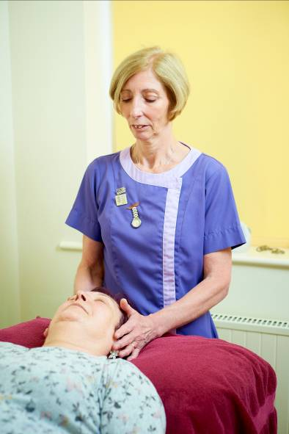 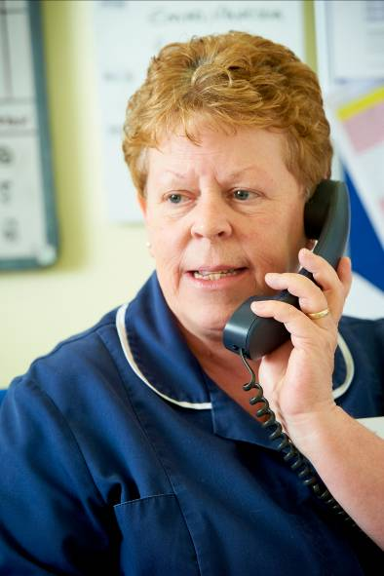 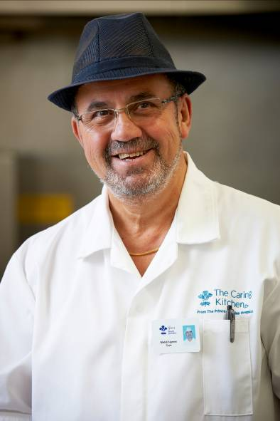
Applying for this role

Should you want to be considered for this exciting opportunity, the next step is to complete an application form, tailored to the person specification and job description. To give yourself the best chance of being invited to interview, please give detailed examples of how you have demonstrated the competencies in the personal statement.

The closing date for applications is: Tuesday 12 November, noon.

Interviews will take place on Wednesday 27 November and will include a presentation task alongside a competency-based interview.

Further questions

To find out more about the role please contact Sharon Batty, Head of Income Generation on sbatty@pwh.org.uk or call 01977 781476.

