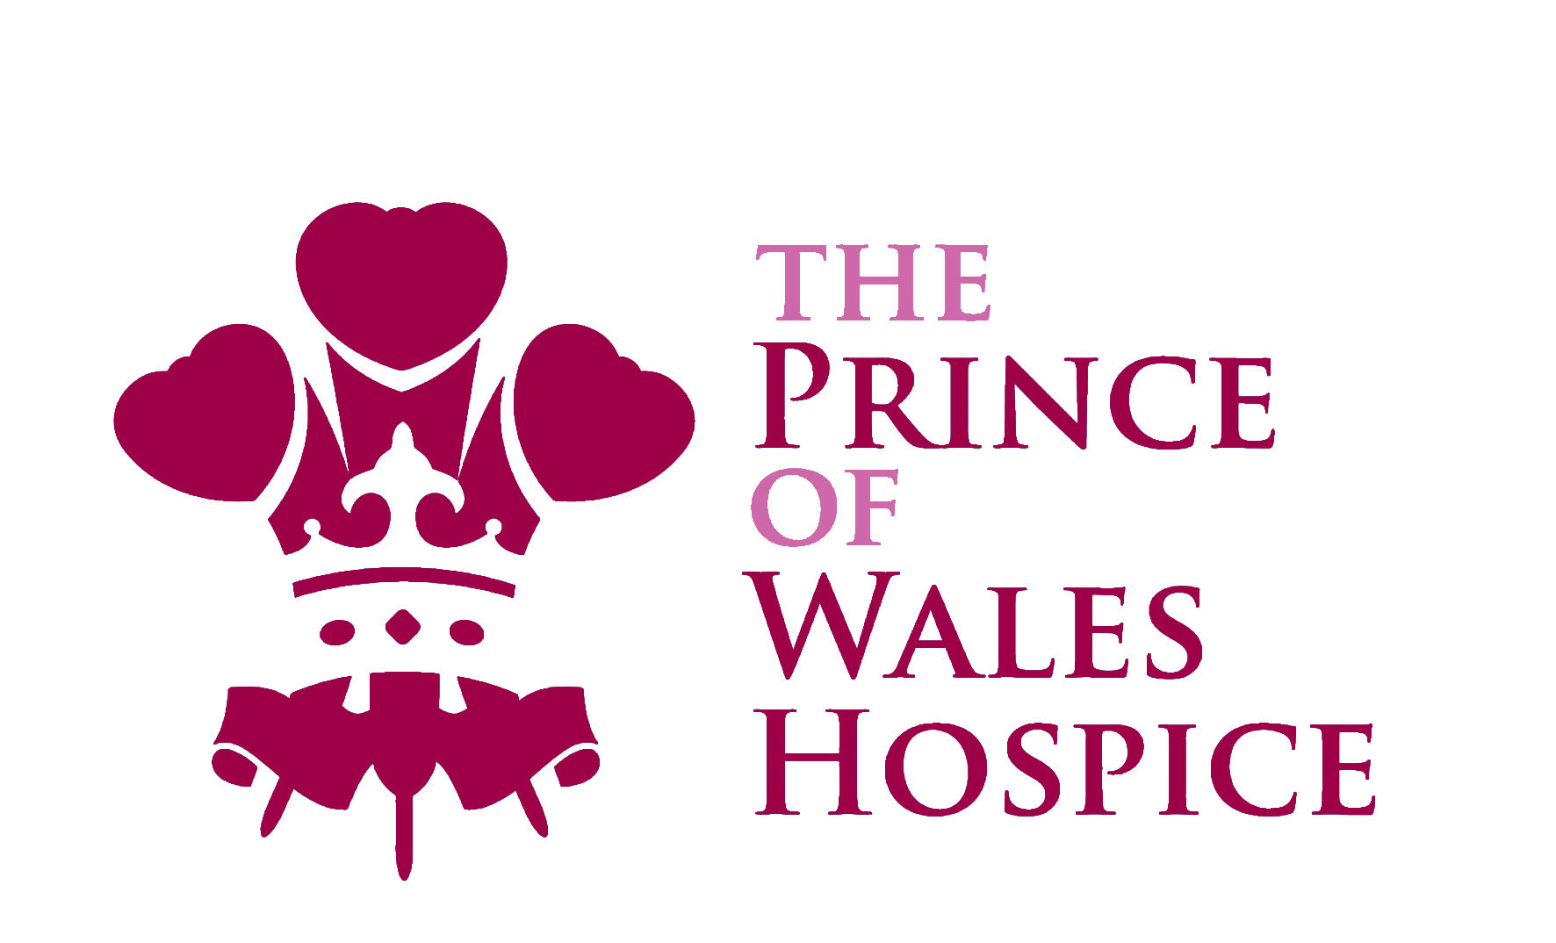
Corporate Partnerships Officer
Full-time (37.5 hours)
Salary £25,037 - £29,321
Come and lead our successful corporate fundraising team at The Prince of Wales Hospice, West-Yorkshire, where no two days are the same!
Our Corporate Fundraising Team already raise over £150,000 pa for The Prince of Wales Hospice. But with an ambitious plan for patient care, we need to increase this fundraising further.

Within a broader fundraising team, you will manage our Corporate Partnerships team, responsible for the development, planning and delivery of a programme of fundraising campaigns and products which appeal to a wide range of businesses. You will play a key role in everything from agreeing budgets and targets, to liaising about marketing materials, ensuring campaigns run smoothly and that your team’s activities provide an excellent return on investment. You will deliver impeccable stewardship to help maximise income and develop long term relationships.

Our ideal applicant is passionate, enthusiastic and self-motivated to achieve beyond targets. You will need to be flexible, resilient and a strong team player and also have excellent interpersonal skills, strong organisational skills and the ability to juggle competing demands. With a minimum of two years proven account management experience you will deliver a successful and highly professional service. We are looking for someone who can work closely with the others in the Fundraising, Marketing and Retail Teams and with the fundraising volunteers who support all of our work.

Please note that a full driving licence and access to a vehicle are required for this role.

Applying for this role

To be considered for this role, download a role profile, person specification and application form from www.pwh.org.uk/vacancies. The closing date for applications is: Monday 2nd December 2019 at 12.00 noon.

Interviews may include a presentation, written task and competency-based interview.

To find out more about the role please contact Sharon Batty, Head of Income Generation on sbatty@pwh.org.uk or call 01977 781476.

The Prince of Wales Hospice
Halfpenny Lane, Pontefract, WF8 4BG
Registered charity 514999

